# IN LAB ACTIVITY 1

1. **List up to 4 different protocols that appear in the protocol column in the unfiltered packet-listing window**.

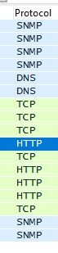Following is the list of 4 different protocols:

* 1. SNMP
  2. DNS
  3. TCP
  4. HTTP

1. **How long did it take from when the HTTP GET message was sent until the HTTP OK reply was received?**



Time taken = time of OK reply – time of request

= 4.72 - 4.69

= 0.03 seconds

1. **Was the second Get Request successful? How can you tell it from the corresponding response packet?**



No the second request was not successful. We can see that after GET request 404 status code was sent from the server which means “Not found”.

1. **Is your browser running HTTP version 1.0 or 1.1? What version of HTTP is the server running?**

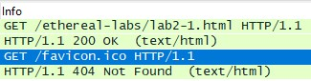

In the info of the packets from server, HTTP version is stated. It indicates that http 1.1 version is used.

1. **What languages (if any) does your browser indicate that it can accept to the server?**



It can accept only US-English language.

1. **What is the IP address of the gaia.cs.umass.edu server and your computer?**

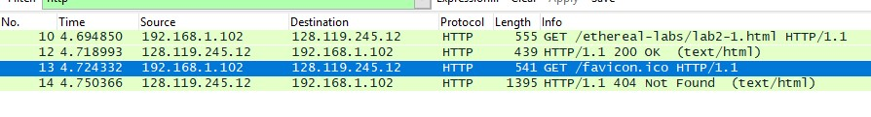

The IP address of giaa.cs.umass.edu server is 128.119.245.12.

1. **What is the MAC address of the server and your computer?**

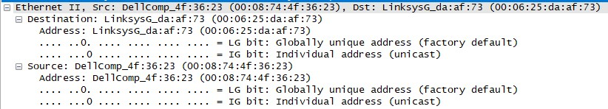

The MAC address of our PC is the MAC address of src i.e. 00:08:74:4f:36:23

1. **What is sending and receiving Port Number? What does Port No. 80 represents?**

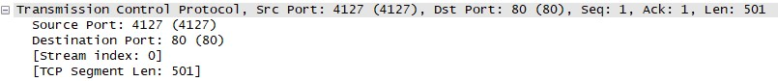

The sending port number is 4127 and receiving port number is 80. The 80 port number is used by http protocol. SO it represents that an http request is being made.

1. **What is the status code returned from the server to your browser?**



In the first response 200 status code was returned and in second 404 was returned.

1. **When was the HTML file, that you are retrieving, last modified at the server?**

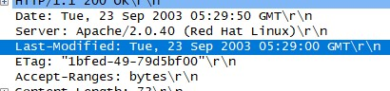

It was last modified on Tue, 23 Sep 2003 05:29:00 GMT;

1. **How many bytes of total packet content are being returned to your browser?**



The content length is 73 bytes.

1. **Inspect the contents of the first HTTP GET request from your browser to the server. Do you see an “IF-MODIFIED-SINCE” line in the HTTP GET?**

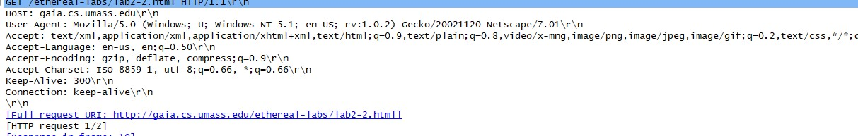

The first HTTP GET request does not have any “IF-MODIFIED-SINCE” line

1. **Inspect the contents of the server response. Did the server explicitly return the contents of the file? How can you tell from the Packet Bytes Window?**

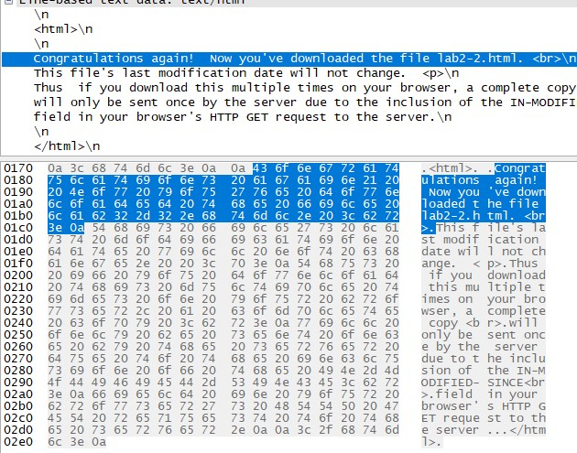

Yes server did explicitly returned the contents of requested file. We can see that after all the header info, file content is stated/

1. **Now inspect the contents of the second HTTP GET request from your browser to the server. Do you see an “IF-MODIFIED-SINCE:” line in the HTTP GET? If so, what information follows the “IF-MODIFIEDSINCE:” header? What is meant by this information?**

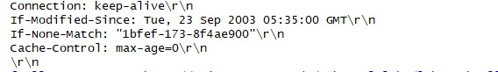

Yes there exists an “IF-MODIFIED-SINCE” line in the second request message. If the file is not modified since the stated date and time the cached data can be displayed at user’s end.

1. **What is the HTTP status code and phrase returned from the server in response to this second HTTP**

**GET? Did the server explicitly return the contents of the file? Explain your answer**



The status code 304 is returned which means that file requested has not been modified since the “IFMODIFIED-SINCE” value sent in the get request.

# IN LAB ACTIVITY 2

1. **How many HTTP GET request messages did your browser send?**



One http request is made from the browser.

1. **Which packet number in the trace contains the GET message for The Bill of Rights?**



The packet number 8 contains the GET message for “The Bills of Rights”.

1. **Which packet number in the trace contains the status code and phrase associated with the response to the HTTP GET request?**



The packet number 14 contains the status code and associated status phrase.

1. **What is the status code and phrase in the response?**

The code is 200. And associated phrase is OK.

1. **How many data-containing TCP segments were needed to carry the single HTTP response and the text of the Bill of Rights? What are the numbers of those packets?**

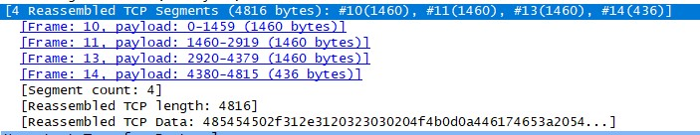

These 4 TCP segments were needed to carry the single HTTP response and the text of “The Bills of Rights”. And 4 packets are used.

# IN-LAB ACTIVITY 3

**What is the length of the text for The Bill of Rights in bytes? How do you justify this length of text when your Response Packet Size is only 490 bytes? Give complete explanation how the length of text in various packets add up to a total of 4500 Bytes.**

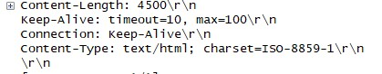

The length of text is 4500 bytes. The response packet is the handshake control packet sent from the server which contains the data required to set up connection. The remaining data is sent through TCP connection.



The total packets add up to form 4816 bytes, which is greater than 4500. The remaining data i.e. 48164500 = 316 bytes is the header info which is necessary while communication.